**Autonomous Response Drone**

Project Report

by

CMPE 195A

Ali Baqar

Maxwell Cheshier

Brian Josefowicz

Anahit Sarao

[Project Advisor’s Electronic Signature]

_________________________

[Your Supervisor’s Name], Project Advisor

08/2017

**ABSTRACT**

**Autonomous Drone Police Aid and Assailant Deterrent**

By Ali Baqar, Maxwell Cheshier, Brian Josefowicz, Anahit Sarao

College campuses have always dealt with criminal offenses and are always attempting to make these campuses safer for students. Most of the crimes that take place are burglaries, sex offenses, and theft. The police’s only response to this situation is to send out officers to the scene of the crime in hopes of catching the assailant in the act. With police forces struggling to catch the assailants, this can lead to a general feeling of unsafety. A school which lacks safety could possibly see fewer students enrolling out of fear of the campus. Additionally, the only deterrents the police have for this type of behavior is the use of security cameras which can be ineffective for the job required of them. Many of the assailants are able to escape and remain uncaught while relying solely on the victim’s description of the assailant in hopes of finding them. The use of a device which can respond to the situation in time faster than the response speed of police on the ground as well as aid the individual being attacked would serve as both an aid to the police and a deterrent against the attacker.

The current problem faced by police forces in attending to the aid of individuals is their slow response speed. If they are lucky, there will already be a unit on campus, however, if not, a unit will have to be deployed from their station which would reduce response time and their effectiveness. This slow response time often results in the escape of the attacker where they can’t possibly identify him or her. The use of cameras can help to solve them but it’s possible that these cameras either aren’t sensitive enough, lack a proper field of view, or simply aren’t in that location. Additionally, the cameras can’t aid the victim while they are being attacked which does not help in hindering the assailant. When cameras aren’t present, there is no way to identify the attacker besides witness descriptions. These descriptions can be faulty or lacking in detail and ultimately don’t often result in apprehending the attacker.

The drone will act as a first responder to a potential crime happening on campus. The drone will be able to reach the destination of where an attack is taking place faster than the police can respond. When the button is pressed to signal the police to an emergency, the drone will be signalled to attend to the location specified. When the drone responds, it will capture images of the location where it was sent in the form of video or still images, in order to aid in capturing photographic evidence of the attacker. This will allow the drone to both deter attacks and aid in identifying and apprehending the aggressor through image capturing. The use of an autonomous drone will allow the police to mobilize without the need of a “pilot” as well as allowing the drone to fly according to its program avoiding possible human error. The drones are also cheaper and more expendable than police lives resulting in a safer and more economical form of police aid. This drone will serve as an invaluable police aid and also a criminal activity deterrent.

**Table of Contents**

**Chapter 1 Project Overview**

* 1. Project Goals and Objectives
  2. Problem and Motivation
  3. Project Application and Impact
  4. Project Results and Deliverables

**Chapter 2 Background and Related Work**

* 1. Background and Technologies
  2. State-of-the-art

**Chapter 3 System Design**

3.1 Architecture Design

3.2 Design Constraints, Problems, Trade-offs, and Solutions

**Chapter 4 Current Status**

4.1 Status of Design and Implementation

4.2 Initial Results

**Chapter 1. Introduction**

* 1. **Project Goals and Objectives**

The autonomous drone has several goals in mind. The ultimate goal is to provide a safer college campus by deterring criminal activity as well as apprehending the criminals that commit these offences. In order to achieve this, the drone will have to operate autonomously by receiving a signal and properly flying to the location where the distress signal was triggered. From that point, the drone will need to begin recording images of the attacker whether in still frames or video. This process will also occur while the drone is flashing lights or providing a spotlight to illuminate the scene in order to hinder the assailant. After the police arrive on the scene, they will send a signal to the drone indicating for its return to base. The drone will then return to base where it will go into a standby mode awaiting another distress signal.

This drone aims to aid in the prevention of criminal activity on college campuses. Many of the activities that take place on college campuses can be prevented or prevented from escalating with the use of a fast response device aimed at alerting nearby individuals and alarming the attacker. With the increase in drone popularity and the advances in the field of automation, this project is a foreseeable step forward in the advances of security and automation.

* 1. **Problem and Motivation**

San Jose State University is at the heart of downtown San Jose which is notorious for homeless and criminal activity. Often this sort of activity can drift onto San Jose State’s campus and lead to crime that impacts students. While San Jose campus police have attempted to become more transparent and active with the criminal activity happening through SJSU alerts, this often leads to a greater feeling of unsafety and lack of police power. To deal with this, some changes must be made in how the police go about apprehending criminals and preventing any sort of criminal activity.

To properly act as a deterrent and aid for police, the drone must cause the assailant a sense of panic resulting in them fleeing the scene and additionally must be able to assist the police in identifying the suspect. The drone will cause this sense of alarm and panic through the use of lights and sounds that will have the capability of alerting bystanders and additionally assisting the police in quickly acquiring the location of where the distress signal was sounded. The drone will come to the aid of the victim and scare away the attacker’s while also providing crucial evidence to the police.

* 1. **Project Application and Impact**

The results of this project will develop a safer college campus where these drones are implemented. This will have a societal impact in creating a more enticing college experience where individuals don’t fear for their safety. With individuals not worrying about their safety, they will be able to focus properly on their academics resulting in more successful students and graduates. The use of these drones will also impact industry resulting in drones being utilized in more aspects of society. Drones may see use throughout cities in the delivering of goods or even see expanded use of their current application in police forces in urban areas. Currently, drones are seeing use by police forces in urban areas, however, these forces are manned which detracts from man power that could be used more effectively [Glaser].

The use of these drones may also have adverse effects on society. The use of drones may call into question the possible infringement on people’s fourth amendment rights. People may feel that they did not actively consent to the use of these drones for their surveillance purposes. This may result in possible legislation being passed either in favor or opposition to the use of drones and will have many implications on the future of drones.

* 1. **Project Results and Deliverables**

The expected results of this project is a system in which to call a drone to a location in order to provide assistance to someone being attacked as well as provide valuable information to whoever owns the drones, ideally the police. This system will be a composition of hardware tools such as the drone itself, microcontroller, IR sensors, as well as the adaptation of open source code responsible for autonomous flight. The edits to the code will allow for the drone to fly to a desired location as well as take certain routes according to our preferences written into the code. These preferences will help to avoid collisions and allow the drone to take a more streamlined and optimal course to the location.

The deliverable for this project will be a prototype of the drone outlined in this report. The prototype will be designed to implement the features outlined, however, it may not be executed in the most desirable fashion. This means that the design could be improved upon to make it faster and more efficient. Both of these features will make the drone more desirable and additionally reliable. The prototype will act as a barebones model in which possible upgrades could be implemented based on the consumer’s needs. Upgrades may include a sturdier frame for durability, more powerful motors for increased speed and acceleration, or other peripheral upgrades such as motion detector. The drone will ultimately have the ability to autonomously fly to a location, perform reconnaissance, aid the victim, and return to its original location. **Chapter 2. Background and Related Work**

* 1. **Background and Technologies**

Drones have been used by the military for decades and up until quite recently they haven’t been readily accessible to the public. Within the past decade we have seen a lot of innovation in the drone industry. We are beginning to see the various applications of drones not only for military use but for things such as agriculture, exploration of areas and to help the community in ways that don’t endanger other lives; a search and rescue team could send an autonomous drone into a fire versus them risking their life to do the same job.

Drones are either controlled by a remote controller or some type of pre-programmed response which is why they are commonly used by military or hobbyist.

With all the drones having surveillance capabilities we have to have some way to control it and that’s where the software portion comes in. We have a mounted camera on the drone that records what is going on in the surroundings and that it being controlled by some type of software. The Viewpoint software is a good platform to control the mounted camera and gives the user the flexibility to point the camera wherever they want. This obviously comes into the category of surveillance which is why for certain drones it is required to register them with the FAA(Federal Aviation Agency) and in some cases you have to obtain certain certifications from them to operate the drones.

Drones and the software that has been uploaded to the hardware can serve different purposes. DroneDeploy is a popular software that allows people to process maps, interpret data and 3D modeling. With the amount of sensors that are available we can use the drone for many different purposes and have it gather and analyze different types of data.

The coding can get really complicated when dealing with the drone and the camera interacting together. There are currently multiple autopilot softwares that take care of that and allow us to make our own edits to it. The one that we are currently playing around with is called Paparazzi UAV(Unmanned Air Vehicle) and it provides us with a bunch of libraries that have different functionalities. The code is mostly written in Python and there is a lot of Matlab involved as well for the processing of the maps that the camera is capturing.

**2.2 Hardware**

Almost all autonomous drones in the market right now implement some sort of flight controller software that fully utilizes the sensors onboard to allow the drone to be controlled autonomously. The most common flight controller that is open-source is Ardupilot, it provides multiple different functionalities for a variety of different uses. The autopilot software currently requires some embedded hardware that is compatible with what needs to be done and the most commonly used one with Ardupilot is the Pixhawk. The pixhawk has a 32-bit ARM cortex M4 core with FPU which is running at 168 Mhz/256 KB RAM with 2MB Flash ROM. It come with a variety of sensors that allow the drone to autonomously fly with respect to its environment. It has a MPU6000 accelerometer and gyroscope along with a ST Micro 14-bit compass/accelerometer which they call a magnetometer. The altitude is measured and monitored with a MEAS barometer.

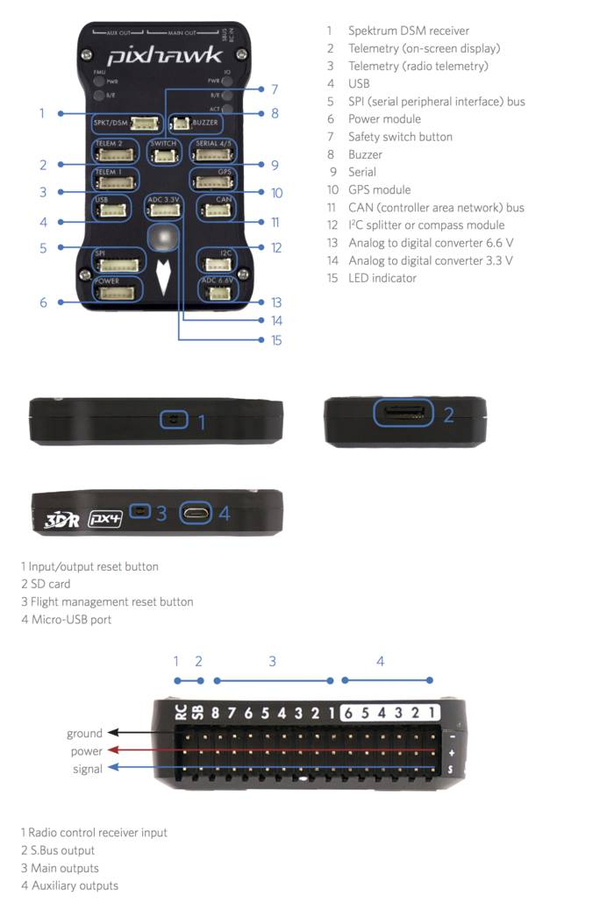

*FigureX. Pixhawk connector assignment and basic hardware layout.*

**Software**

The software that is used to control the drone is equally important and requires a lot of work if done from scratch. There are a lot of open-source flight controller software’s that are available the most common one being the mission planner with the Ardupilot. The features that it allows are the main reason it is widely implemented; it allows users to download mission log files and analyze them. You can interface with the PC flight simulator to create a full hardware loop, which basically is what allows the drone to fly autonomously. You can use any of the common communication methods to connect the mission planner to the autopilot software i.e. Bluetooth, radio, USB cables and IP connections. A basic layout of the mission planner is given in figureX.

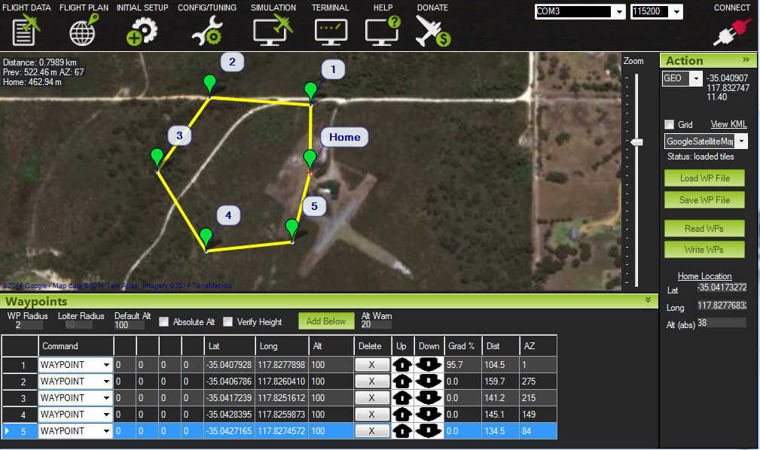

*FigureX. Mission Controller layout.*

**2.4 Current Methods of Implementation**

Currently drones are used for many different purposes, there is a huge hobbyist market along with a fastly growing developer market. One of the main advantages of using autonomous drones are that you can program a specific function for it to complete and you won’t have to manually control it. This complicates things a bit as well. For manual control of a basic quadcopter as shown in FigureX (CrazieFlie 2.0-our drone), you only need three basic controls, roll, yaw, and pitch. However, when entering the world of autonomous drones you need to know the position of your’ drone with respect to its environment; moreso the UAV needs to know where it is in 3D in order to make sure it can proceed.

The current method of autonomous control for the CrazyFlie 2.0 is using a “Flow Board” which is basically just an optical flow sensor and a ToF(Time of flight) sensor. The Flow deck consists of a VL53L0x ToF sensor and a PMW3901 optical flow sensor. The ToF sensor gets the distance to the ground with high precision and the optical flow sensor tracks the movement of the drone with relation to ground. The other part of getting the CrazyFlie 2.0 to fly autonomously is through the use of the location positioning nodes and location positioning deck that is available through bitcraze. The way it is currently works is the loco positioning deck communicates with the nodes and figures out the distance from the nodes and uses that to figure out its position. This works in a room but doesn’t work for the application that we were intending it to use.

**2.5 State-of-the-art**

The drone market is flooded with drones specific to the the individual needs of the person purchasing the drone. The drone is growing at an exponential rate, according to an article on recode global sales grew about 60 percent in the last year, with the hobbyist market almost doubling. Drones are becoming more compatible and some can even be controlled through the Android platform [14]. The leading company in the hobbyist community is definitely DJI which make drones with excellent video and photo functionalities. The current drone they offer which is considered the best in the field is the DJI Mavic Pro which can go up to 65 mph and has 27 minutes of fly time. It has a range of about 7 km and has a 3-axis gimbal attached to the camera. Currently we are looking into editing and making changes to their drones if possible. In terms of having a stable drone that we can use to perform the functionality we need, it would be better to try and “hack” their software and make the necessary modifications.

There is also a growing market for drone racing, it’s to the point where people are talking about drone racing being an actual sport. Most drones outside of racing racing drone are using LiPo(Lithium Polymer) batteries for the following reasons: low profile and rechargeable, sizeable charge density, and with high C ratings can deliver lots of current without too much degradation. A pretty good racing drone that we examined was the KingKong 210GT. The components used on this drone were something that we considered, however we later decided not to pursue this drone due to the controller software being incompatible with our expertise. The 210GT runs the F3 flight controller, which is a suitable product; however, we wanted something that would be more open source and developer friendly where we could make some modifications. **Chapter 3. System Design**

* 1. **3.1 Architecture Design**

ARD is designed around the concepts of stability, simple assembly, and modular simple maintenance. The chassis is a *XIRO drone* frame which features a quad motor configuration with blade style propellers, and a retractable quad leg landing gear system. The chassis is able to house the several primary components: Crazyflie 2.0 chassis and microcontroller, BigQuad expansion deck, electronic speed controller (ESC), and the situational record unit (SRU). The overall chassis is made of formed plastic, and houses several built in components: 4 DC brushless motors, LED’s, and system wiring for easy integration.

The core of ARD is the SCB, which is a Crazyflie 2.0 micro controller built around the STM32F405xx processor, which outputs PWM signals to the ESC for motor control. This board also contains several components required for aerial embedded systems: pressure transducer for altitude sensing, 3-axis accelerometer for tilt angle sensing, 3-axis gyro for rate sensing, and a 3-axis digital compass which helps the drone find its heading with respect to true north. It also uses the nRF51822 radio and power management MCU which is a Cortex-M0 architecture. This board performs a dual purpose as it is used for power management as well.

The ESC is a 4-channel DC-AC controller. It takes in 4 separate PWM signals from the SCB (one for each motor), and distributes the signals to their addressed motor. It utilizes a 12V DC power from a 5200mAh Li-Po battery that is rated at 20C. The ESC can handle a distribution of up to 20A across for each AC Brushless motor.

The motors are each rated for 100W, and take in 3-phase AC. They are axial-flux motors which means their outer housing rotates as the electromotive force is applied to it. This means the motors are efficient as compared to DC brushless.

All electronics with the exception of the high powered components (motors and servos), will be powered by a filtered and regulated 240 mAh LiPo battery. This will allow the engineers to power any onboard device via their respective power port (e.g. USB port, through-hole header, screw terminal fastener, etc). The board offers simplicity in terms of power management and application to ensure long lasting life.

For the user interface, there will simply be a handheld device such as a mobile phone with an application where the user can just send a request to the main station, and that will in turn activate the drone. It maintains a constant broadcast for the drone to map its way to the user in distress. Once the range has been minimized, the drone will then know the location of the user, as be able to capture the on scene information.

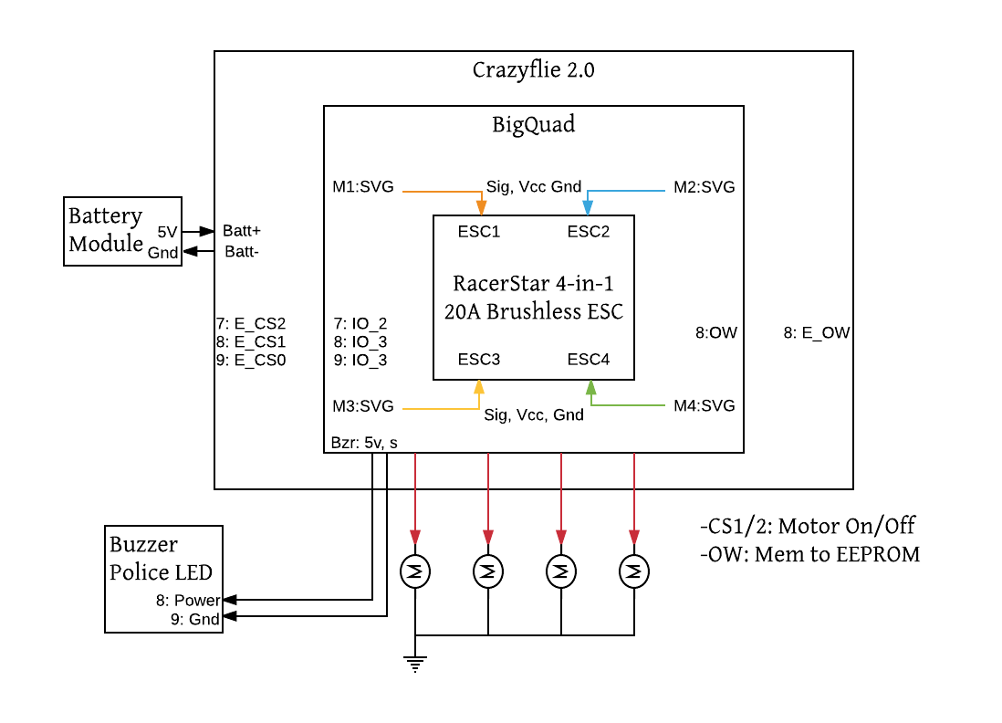

Figure: ARD Central Stack

* 1. **Design Constraints, Problems, Trade-offs, and Solutions**

Throughout the process of planning and development, engineers must foresee the possible setbacks in order to mitigate risk, and have a chance to design around the issues that can arise from unforeseen failures. Certain parameters play a key role in creating the proper design plan going forward, and here are the factors that were considered during the planning and design process.

* 1. **3.2.1 Design Constraints and Challenges**

The primary design constraint is of course time. We need to be sure that our design fits our capability to deliver a working product on time including testing, regression, and possible changes that may occur. Similarly, we are limited on financial contribution which means we need to not only build a reliable product, but a cost effective one too. Individual mistakes turn into sunk costs, so it is a goal to minimize the reality of these risks.

A large constraint is ensuring proper integration between hardware and software. In our design, we will be modifying the drone to take on a larger chassis. With these modifications, unforeseen circumstances may arise. The drone may not be able to generate enough power with the new chassis or the drone’s balance may be thrown off. These types of challenges have to deal with and overcome either with additional hardware modifications or modifications to the software. In order to have a successful autonomous drone, the drone’s hardware must be able to work effectively with the software. The drone must properly relay information from the sensors, and the code we implement must adjust accordingly.

While there are some hardware changes being performed on the drone, those challenges are miniscule compared to the challenge of programming for autonomous flight. The drone will largely act like a state-machine, following various states to achieve takeoff, flight, and landing, however, these steps themselves are very intricate. In order to execute autonomous flight, the drone must be able to recognize the location of a signal and properly reach that destination. This includes using its own sensors to avoid obstacles, and that can be implemented with sensors that mimic vision for the drone, or exteroceptive sensors [6]. Using IR or laser sensors, the drone will be able to accurately tell the distance from an object and following its programming, be able to avoid it and continue. The drone will also have to ensure that its in proper working order to be able to make the flight. Damage to certain sensors or a low battery would hinder the success of the drone flying to its destination. The drone will make use of proprioceptive sensors which monitor the drone’s internal status [6]. This will ensure safe flight and prevent damage to the drone or to any objects or people.

**3.2.2 Design Solutions and Trade-offs**

To compensate for the low load capacity of the CrazyFlie, an additional chassis and ESC were purchased. These additional components will allow for us to carry a heavier payload and provide more stable flight. With this additional chassis comes extra weight. The trade-off of being able to generate more power is that the drone will consume more power from the battery. With this in mind, a shorter flight time and more consistent charges will be required, or the purchase of a larger battery may be necessitated.

The use of external, third-party sensors is a solution we came to in order to provide a more accurate and controllable object detection system. Compared to other drones which are equipped with cameras, the sensors will work more effectively and do not necessitate creating an object detection algorithm based on a 2D image. The drawback of using third-party sensors compared to the proprietary components is that they may be harder to manage. While it may not be simple plug and play like the cameras that come standard on some drones, the CrazyFlie’s expansion connectors and implementation of the big quad deck will allow for simple integration of various third-party sensors and components.

**Chapter 4. Current Status**

**4.1 Status of Design and Implementation**

At this current venture, our team has finalized our approach on the design and have gone forward with purchasing and testing with what is available to us. We have been able to perform several tests on the CrazyFlie provided to us by our advisor and plan to continue testing. We have been able to control the CrazyFlie in various manners whether it be from a phone or even utilizing a Playstation 3 controller. This proves to be promising and will allow for us to perform more precise tests.

We have found that the CrazyFlie in its current state will not be able to carry the additional weight we plan to add from the camera and sensors. The CrazyFlie maximum recommended payload is 14 grams [2] and the weight of a Raspberry Pi zero and SD card is 8.8 grams, with a pin header is 11.8 grams [3], and that’s without considering the additional weight of the camera and sensors. To compensate for this, we purchased a larger chassis which will allow for the drone to carry more weight.

**4.2 Initial Results**

In our initial testing of the drone we came to find out that the CrazyFlie is very hard to control. The drone was very unstable and this often resulted in the drone becoming uncontrollable. When attempting to fly, some components were easily damaged requiring repair in order to make the drone serviceable. We were able to control the drone in a variety of ways and have attempted to repair the drone in order to allow us to put the drone into bootloader mode. Boot loader mode allows us to flash the firmware and put our own custom code on the drone [4].

We have also began testing on the Raspberry Pi module. We installed a camera module and have developed code which allows for us to take both pictures and video.

**4.2.1 Next Steps**

There are several steps to be taken in order to complete our minimum viable product. First we need to be able to increase the power and control of the drone. The increased power will be accomplished by adding a larger chassis and adding an electronic speed controller. Another required step will be making a more stable flight. The controller for the drone is already equipped with a 10 DOF IMU. The 10 DOF IMU provides us with 10 axes of data: 3 axes of accelerometer data, 3 axes of gyroscopic data, 3 axes of magnetic or compass data, and barometric pressure [5]. Using these sensors, we will be able to optimize our code to take in these various axes and provide more stable flight.

The largest step required will be the autonomous flight aspect. This will be accomplished by integrating the sensors attached to the Raspberry Pi with the drone. The Raspberry Pi will have to be able to communicate with the controller and tell the drone what is going on and how to fly. The Pi will need to act as the eyes for the drone to detect obstacles in order for the drone to properly avoid them. It would be a monumental task to program an autopilot software for the drone. Instead, we will be taking advantage of some of the open source projects where auto piloting software has been developed. It is still a tall task to have the drone even communicate with the sensors, but getting the initial stage of coding up and running will be a significant step in the right direction.

**References**

[1]A. Glaser, "Police departments are using drones to find and chase down suspects", *Recode*, 2017. [Online]. Available: https://www.recode.net/2017/4/6/15209290/police-fire-department-acquired-drone-us-flying-robot-law-enforcement.

[2]"projects:crazyflie2:hardware:specification [Bitcraze Wiki]", *Wiki.bitcraze.io*, 2015. [Online]. Available: https://wiki.bitcraze.io/projects:crazyflie2:hardware:specification.

[3]"Raspberry Pi Zero weight & power consumption | mitat.tuu.fi", *Mitat.tuu.fi*. [Online]. Available: http://mitat.tuu.fi/?p=423. [Accessed: 10- Aug- 2017].

[4]"doc:crazyflie:bootloader:index [Bitcraze Wiki]", *Wiki.bitcraze.io*, 2015. [Online]. Available: https://wiki.bitcraze.io/doc:crazyflie:bootloader:index.

[5]"Crazyflie 2.0", *Bitcraze Store*, 2017. [Online]. Available: https://store.bitcraze.io/products/crazyflie-2-0.

[6]G. Bekey, *Autonomous Robots: From Biological Inspiration to Implementation and Control*. Cambridge: MIT Press, 2005, p. 11.

[7]"projects:crazyflie2:architecture:index [Bitcraze Wiki]", *Wiki.bitcraze.io*, 2015. [Online]. Available: https://wiki.bitcraze.io/projects:crazyflie2:architecture:index.

[8]"STM32F405RG - High-performance foundation line, ARM Cortex-M4 core with DSP and FPU, 1 Mbyte Flash, 168 MHz CPU, ART Accelerator - STMicroelectronics", *St.com*, 2017. [Online]. Available: http://www.st.com/en/microcontrollers/stm32f405rg.html.

[9]"nRF51 Series SoC / Products / Home - Ultra Low Power Wireless Solutions from NORDIC SEMICONDUCTOR", *Nordicsemi.com*, 2017. [Online]. Available: https://www.nordicsemi.com/Products/nRF51-Series-SoC.

[10]"Mission Planner Home — Mission Planner documentation", *Ardupilot.org*, 2016. [Online]. Available: http://ardupilot.org/planner/index.html#home.

[11]"projects:crazyflie2:expansionboards:bigquad [Bitcraze Wiki]", *Wiki.bitcraze.io*, 2016. [Online]. Available: https://wiki.bitcraze.io/projects:crazyflie2:expansionboards:bigquad.

[12]L. Koh and S. Wich, "Dawn of Drone Ecology: Low-Cost Autonomous Aerial Vehicles for Conservation", *Tropical Conservation Science*, vol. 5, no. 2, pp. 121-132, 2012.

[13]Z. Yu, K. Nonami, J. Shin and D. Celestino, "3D Vision Based Landing Control of a Small Scale Autonomous Helicopter", *International Journal of Advanced Robotic Systems*, vol. 4, no. 1, p. 7, 2007.

[14]R. Faragher, O. Chick and D. Wagner, "Captain Buzz: An all-smartphone autonomous delta-wing drone", *Workshop on Micro Aerial Vehicle Networks, Systems, and Applications (with ACM MOBISYS)*, 2015.

**Appendices**

**Appendix A –**

[Typical example: you can include a specific standard here.]

**Appendix B – Source Code**

[Typical example: you can include a specific interface details here.]